**Onions and mushrooms: Investigating the potential of edible mushrooms as a novel product of onion waste**

We are pleased to report progress on the two objectives as follows:

1. **Assess the potential of onion waste for the production of three types of edible mushroom: *Pleurotus* spp.and *Lentinula* sp.**

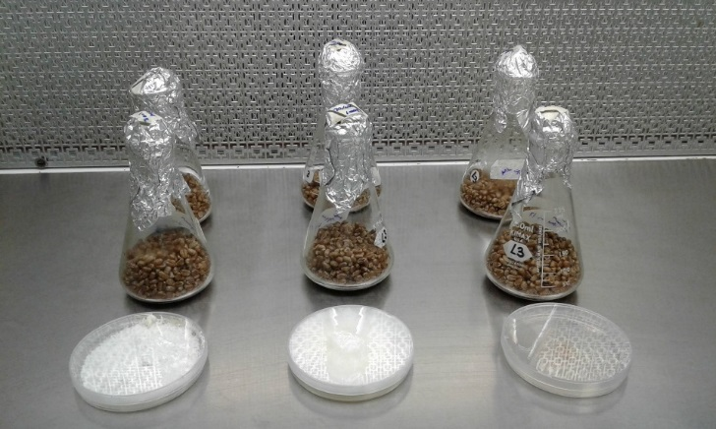A protocol has been established to prepare onion skin waste for inoculation with the mushroom spawn shown in **figure 1**.

**Figure 1** Mushroom grain spawn for Pleurotus spp (left and centre) and Lentinula sp (right)

We have assessed mushroom cultivation in both bags and containers. The following results were achieved using 200g dry-weight onion skin substrates:

***Pleurotus* spp.(Oyster mushroom)**

Both *Pleurotus* strains were able to utilise onion skin waste as the main substrate for mycelial growth. However, we were able to induce mushroom production for just one variety (**figure 2**).

**Figure 2** Early fruiting bodies of Pleurotus sp (left) and mature oyster mushrooms (right) grown on onion skins.

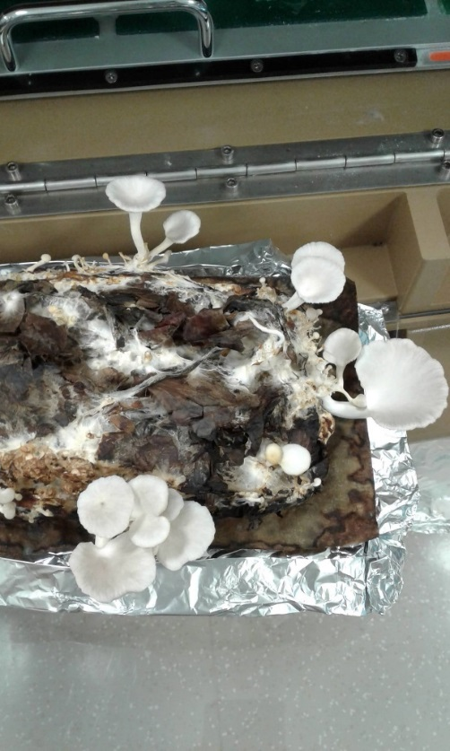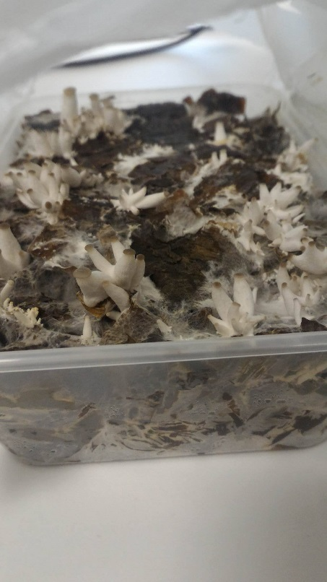

We trialled two different methods for producing mushrooms: in bags and containers (**figure 3**). For both methods, mature oyster mushrooms were produced approximately 30 days after inoculation of the substrate and we have harvested mushrooms from several different trials. These have been stored at -80C for later analysis of mushroom properties.

Currently, we are trying to determine methods to maintain adequate humidity and airflow for mature mushroom formation.

**Figure 3** Mycelial growth of Pleurotus spp on onion skin waste using bags (left) and containers (right).

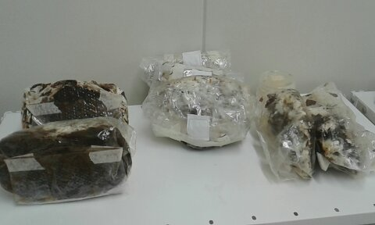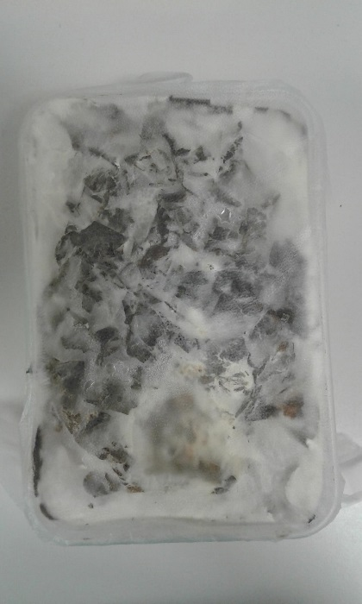

***Lentinula* sp. (Shiitake mushroom)**

*Lentinula* was also able to utilise onion skin waste as the main substrate for mycelial growth. We were also able to demonstrate potential for production of mature fruiting bodies in bags. Fruiting bodies appeared faster than expected-after approximately six weeks. However, these were malformed as shown in **figure 4**.

We are repeating and adapting these trials to determine if fully formed mushrooms can be produced using onion skin. These structures may still have a use as dried mushroom powders or tea products so we will attempt to collect these structures for further compositional analysis.

**Figure 4** Malformed shiitake mushroom structure produced on onion skin waste

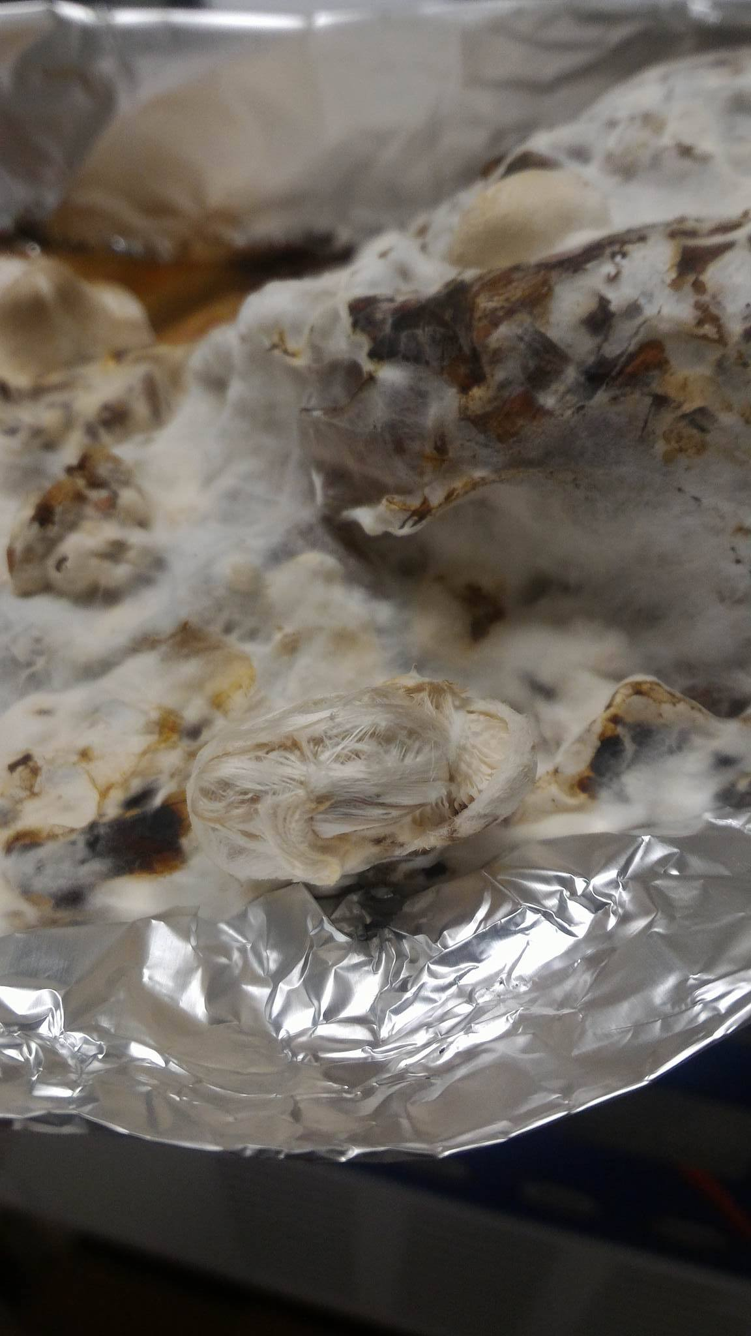

Partial mushroom cap with gills

Stalk arrangement

1. **Compare composition of mushrooms grown on onion waste to traditional, straw or wood grown mushrooms.**

To be completed following collection of enough mature fruiting bodies.