**Project title: Genomic Selection of adaptive traits in onion**

**Name of Student: Jiffinvir Singh Khosa**

**Supervisors: Dr. Richard Macknight and Dr. John McCallum**

**Introduction**

Onion have biennial life cycle in which bulbing occurred during first year followed by flowering in the next year. Bulb is a modified underground stem formed by thickening of leaf bases in response to day length (Brewester 2008). Similar to photoperiodic flowering, day-length perception probably occurs in the leaves, while the response is in the meristem (Brewster, 2008) suggesting a mobile signal with properties similar to *FLOWERING LOCUS T* (*FT*) might be involved in the bulbing. Consistent with this hypothesis, earlier we found that bulb formation is regulated by two antagonistic *FT* genes, *AcFT1* and *AcFT4* (Lee et al., 2013). Once the day-length reaches a critical length *AcFT4* is down-regulated and this leads to the up-regulation of *AcFT1*, which promotes bulbing. Now we are interested to investigate how *FTs* are regulated by upstream photoperiodic pathway genes. In case of flowering changes in day length is detected by photoreceptors to synchronize the circadian clock with environmental cues to activate *FT*. During domestication modifications in the photoperiodic flowering pathway genes allow the adaptation of different plant species to various geographical regions (Nakamichi 2015). We are interested to figure out how bulb onion after domestication adapted to broad range of latitudes as SD and LD types grown at low and high latitudes, respectively.

**Aim: How light quality affects bulbing and *FT* expression**

Earlier, physiological studies shown that bulbing in onions promoted under long days and far red light. The onions never forms bulbs even under long-day conditions when far-red light is low or absent, even for a short duration (Brewester 2008). We grew CUDH 2150 double haploid onions in white light and far red light and found that onions under white light even under long day conditions never form bulbs whereas after onion plants under white light added with far red light form bulb in 26 days of transfer from white light (Figure 1). Then we studied the expression of *FT* in onion plants grown under white and far red light under short day and long day conditions. We found that under onion plants under white light in long days and far red light under short days express *AcFT4* and not forming bulbs. Whereas, onion plants under far red in long days expressed *AcFT1* and form bulbs (Figure 2).

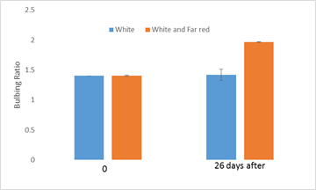 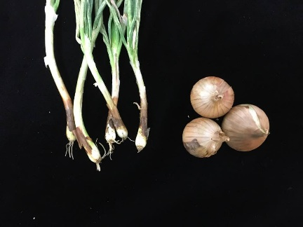

Figure 1: Measure of bulbing ratio under white light and far red light. Bulbing ratio more tha 2 indicate initiation of bulbing.Non bulbing plants under white light wheras bulbs from plants under far red light under long days.

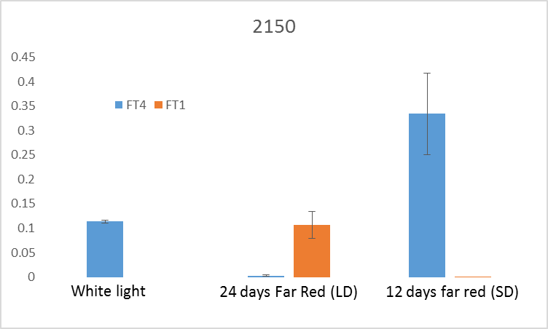

Figure 2: The relative expression of FTs in white light and far red light under short day and long day conditions.

These experiments show for the first time that onion bulb formation requires both long day photoperiods and the right light quality (sufficient far red light) to regulate the key bulbing hormone genes (the two FT genes).

**Aim 2: How different onions performed at critical day length for bulbing**

*FTs* are rapidly upregulated when plants are shifted from non-inductive day length (8hr) to an inductive photoperiod (16hr) in bulb onion and other plants (Lee et al. 2013). To investigate how *FTs* respond in different onions grown at critical day length of 12hr. We found that under 12hr day length only Nasik Red and Albasile (SD onions) form bulb and express *AcFT1*. Whereas, CUDH2150 and CUDH2107 (LD onions) do not form bulbs and expressed low levels of *AcFT4* and *AcFT1* (Figure 3 and 4). These results indicate that at 12hr day length sufficient to downregulate *AcFT4* in long day’s onions but required more than 12hr day length to upregulate *AcFT1* to form bulbs (Figure 4). Earlier, we have shown at 16hr day length long day onions form bulb and expressed AcFT1 (Lee et al. 2013).

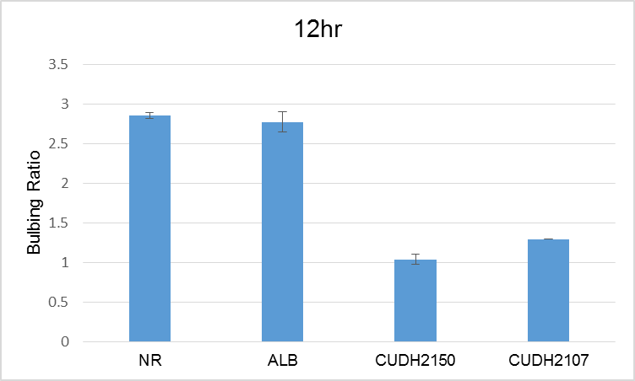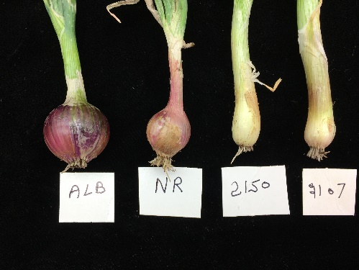

Figure 3: : Measure of bulbing ratio under 12hr day length and bulbing ratio more tha 2 indicate initiation of bulbing. LD onions not form bulbs under 12hr day length but short day onions form bulbs.

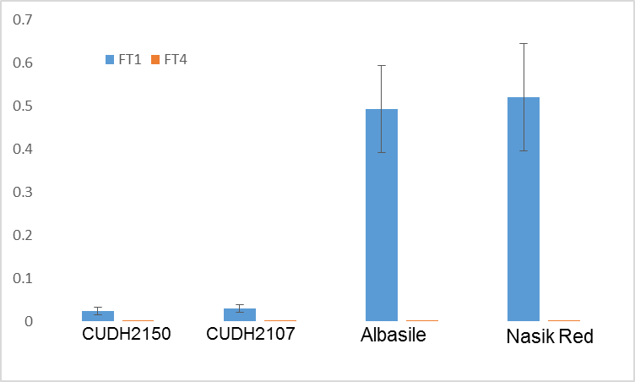

Figure 4: Relative expression of FTs at 12 hrs of day length

**Summary**

Our results show that onion varieties adapted to different latitudes vary in there ability to activate the bulbing hormone (*FT1*). SD onion varieties only require 12 hrs of day length to activate *FT1* and trigger bulbing, while LD onions require 16 hrs of day length to activate **FT1**. This is consistent with our hypothesis that the difference between SD and LD onion varieties is associated with their ability to either percieve or measure the amount of day light they receive. We are currently analysing an F2 population between the SD and LD varieties. In this population, only about a quarter of the plants form bulbs under 12 hrs of daylength. This now gives us a way to work out the genes (or genetic differences in specific genes) that makes a variety either a SD or a LD variety.

**References**

Brewester JL. 2008. Onions and other Vegetable Alliums CABI, Wallingford: 123-149.

Lee R, Baldwin S, Kenel F, McCallum J, Macknight R. 2013. FLOWERING LOCUS T genes control onion bulb formation and flowering. Nature Communication: 4, 2884.