**Project title: Genomic Selection of adaptive traits in onion**

**Name of Student: Jiffinvir Singh Khosa**

**Supervisors: Dr Richard Macknight and Dr John McCallum**

**Introduction**

Onion has a biennial life cycle in which bulbing occurred during the first year followed by flowering in the next year. Bulb is a modified underground stem formed by a thickening of leaf bases in response to day length (Brewester 2008). Similar to photoperiodic flowering, day-length perception probably occurs in the leaves, while the response is in the meristem (Brewster, 2008) suggesting a mobile signal with properties similar to *FLOWERING LOCUS T* (*FT*) might be involved in the bulbing. Consistent with this hypothesis, earlier we found that bulb formation is regulated by two antagonistic *FT* genes, *AcFT1* and *AcFT4* (Lee et al., 2013). Once the day-length reaches a critical length *AcFT4* is down-regulated and this leads to the up-regulation of *AcFT1*, which promotes bulbing. Now we are interested to investigate how *FTs* are regulated by upstream photoperiodic pathway genes. In case of flowering changes in day, length is detected by photoreceptors to synchronize the circadian clock with environmental cues to activate *FT*. During domestication modifications in the photoperiodic flowering pathway genes allow the adaptation of different plant species to various geographical regions (Nakamichi 2015). We are interested to figure out how bulb onion after domestication adapted to a broad range of latitudes as SD and LD types grown at low and high latitudes, respectively.

**Aim: How light quality affects *FT* expression and bulbing**

Earlier, physiological studies have shown that bulbing in onions is promoted under long days and far- red light. Onions never form bulbs even under long-day conditions when the far-red light is low or absent, even for a short duration (Brewester 2008). We grew CUDH 2150 double haploid onions in white light and far red light and found that onions under white light, even under long day conditions never form bulbs, whereas onion plants under white light added with far red light form bulb in 26 days of transfer from white light (Figure 1). Then, we studied the expression of *FT* in onion plants grown under white and far-red light under short day and long day conditions. We found that onion plants under white light in long days and far-red light under short days express *AcFT4* (bulbing inhibitor) and do not forming bulbs. Whereas, onion plants under far-red light in long days expressed *AcFT1* (bulbing activator) and form bulbs (Figure 2).

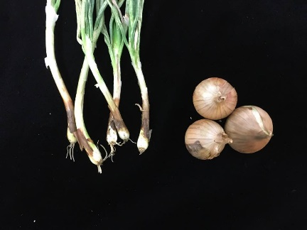

Figure 1: Non bulbing plants under white light wheras bulbs fromed in plants grown under far red light in long days (16hr light and 8hr dark).

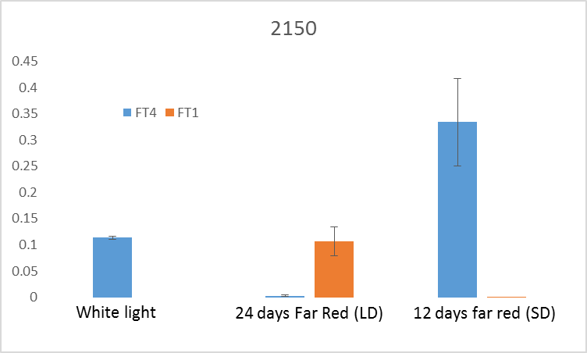

Figure 2: The relative expression of *FTs* in white light and far red light under short day (8hr light and 16hr dark) and long day (16hr light and 8hr dark) conditions.

These experiments show for the first time that onion bulb formation requires both long day photoperiods and the right light quality (sufficient far red light) to regulate the key bulbing hormone genes (*AcFT1* bulbing activator and *AcFT4* bulbing inhibitor).

**Aim 2: How different onions performed at critical day length for bulbing**

*FTs* are rapidly regulated when plants are shifted from non-inductive day length (8hr light and 16hr dark) to an inductive photoperiod (16hr light and 8hr dark) in bulb onion and other plants (Lee et al. 2013). To investigate how *FTs* respond in different onions grown at critical day length of 12hr (12hr light and 12hr dark). We found that under 12hr day length only Nasik Red and Albasile (SD onions) form bulb and express *AcFT1* (bulbing activator). Whereas, CUDH2150 and CUDH2107 (LD onions) do not form bulbs and expressed low levels of *AcFT4* and *AcFT1* (Figure 3 and 4). These results indicate that at 12hr day length sufficient to downregulate *AcFT4* in long day’s onions but required more than 12hr day length to upregulate *AcFT1* to form bulbs (Figure 4). Earlier, we have shown that at 16hr day length long day onions form a bulb and expressed *AcFT1* (Lee et al. 2013).

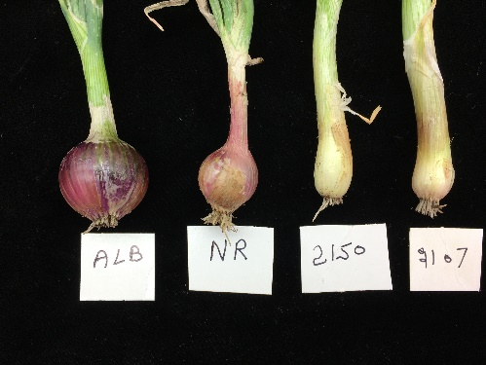

Figure 3: LD onions (2150 and 2107) do not form bulbs under 12hr day length but short day onions (ALB and NR) form bulbs.

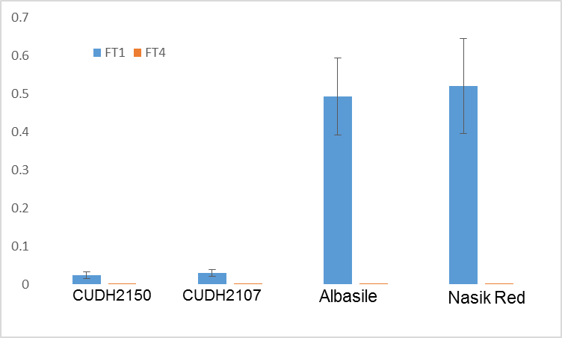

Figure 4: Relative expression of *FTs* at 12 hrs of day length

**Aim 3 Genetic analysis of bulbing in populations derived from SD and LD onion**

We have developed F2 population derived by mass-pollinating clonal F1 top-sets from wide cross crosses between doubled haploid LD (CUDH2107) and adaptively diverse SD onions (Albasile). We grown this population under 12hr day length along with their parents and analyzed seggregation of bulbing. SD parent “Alabsile” form bulbs and express bulbing activator *AcFT1* whereas LD parent “CUDH2107” do not form bulbs and expressed low levels of *AcFT4* and *AcFT1* (Figure 3 and 4). The 65 plants of the F2 population (Albasile X CUDH2107) were grown under 12hr day length and 25C0 in control growth rooms. The segregation for bulbing in F2 population was scored by measuring bulbing ratio (Measure of bulbing initiation >2) and bulbing frequency of ~9.2% (7 bulbing and 58 non bulbing plants) was observed in this population (Figure 5). We conducetd a bulk RNA-seq by pooling non bulbing and bulbing plants from F2 population to identified genetic differences in SD and LD onions for bulbing. In the non bulbing pool, a bulbing repressor *AcFT4* expressed whereas in bulbing pool bulbing activator *AcFT1*. Now, we are identifying SNPs between bulbing and non-bulbing pools and genotyped in large F2 population to determine if there are SNPs segregate for bulbing vs non-bulbing. This will gives us a way to work out the genes (or genetic differences in specific genes) that makes a variety either a SD or a LD variety.

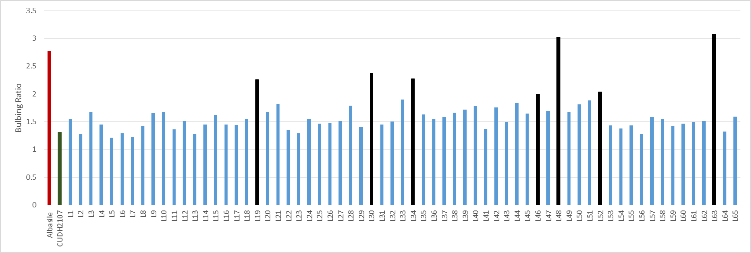 5A

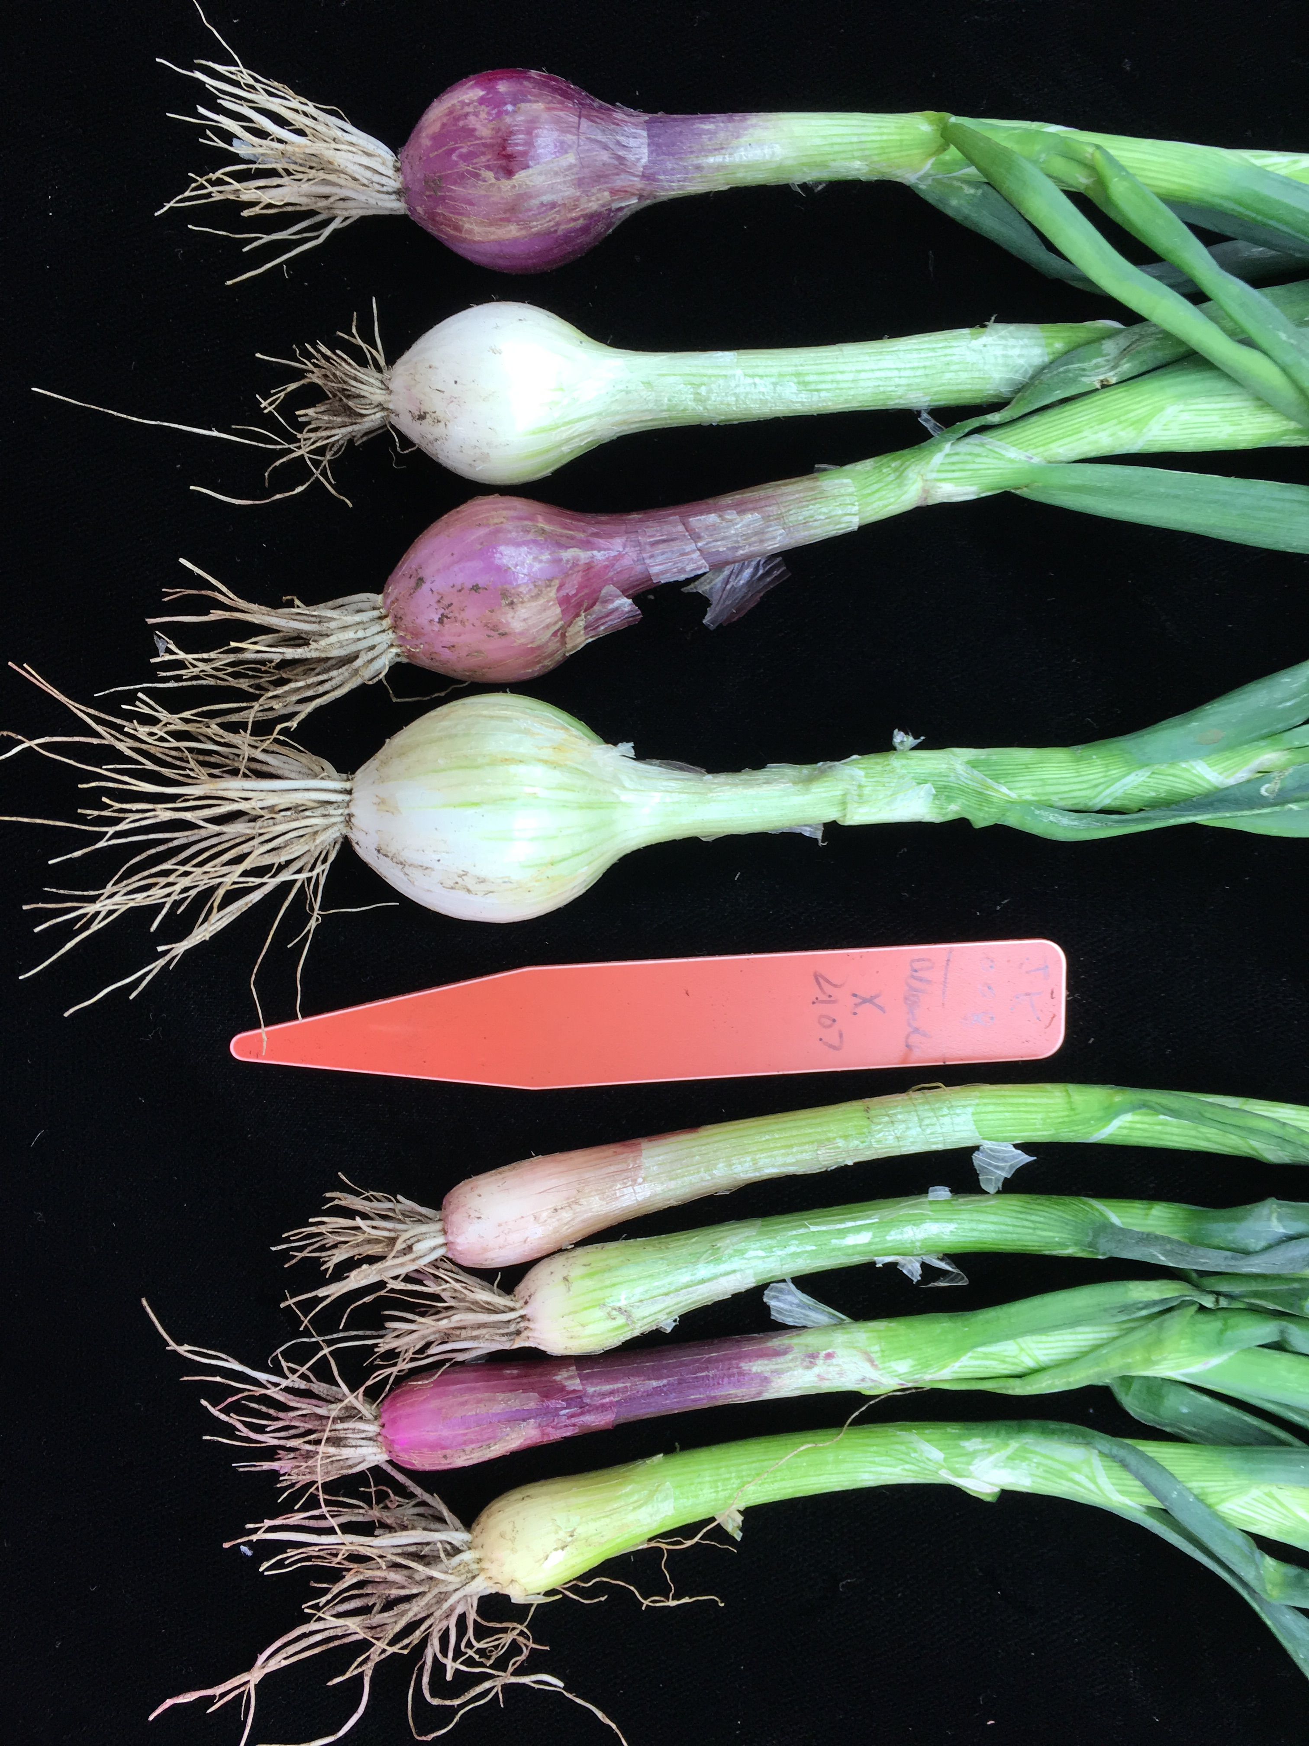 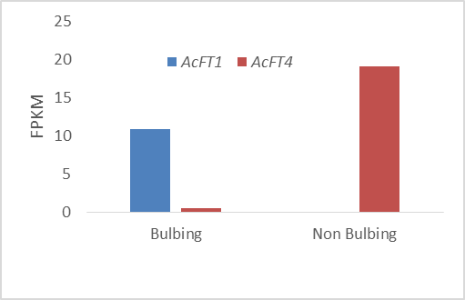

5B 5C

Figure 5: The seggregation and genetic analysis of bulbing in F2 population. Figure 5A shown the bulbing ratio of parents and F2 population. In fig. 5b the phenotype of bulbing and non-bulbing plants in the F2 population. Fig 5c show expression of *AcFT1* and *AcFT4* in bulk RNA-seq pool of bulbing and non-bulbing plants from this population.

**Summary**

Our results show that onion varieties adapted to different latitudes vary in there ability to activate the bulbing hormone (*FT1*). SD onion varieties only require 12 hrs of day length to activate *FT1* and trigger bulbing, while LD onions require 16 hrs of day length to activate *FT1*. This is consistent with our hypothesis that the difference between SD and LD onion varieties is associated with their ability to either percieve or measure the amount of day light they receive. Further, in F2 population grown under 12hr day length the pool of bulbing plants shows high expression of *AcFT1* whereas non bulbing *AcFT4*. Next, we will identify SNPs between bulbing and non-bulbing datsets to identify the genetic differences associated with bulbing segregation.

**References**

Brewester JL. 2008. Onions and other Vegetable Alliums CABI, Wallingford: 123-149.

Lee R, Baldwin S, Kenel F, McCallum J, Macknight R. 2013. FLOWERING LOCUS T genes control onion bulb formation and flowering. Nature Communication: 4, 2884.